

**HORMISDALLEN SCHOOL - KAMWOKYA**

**MID TERM TWO EXAMINATION 2024**

**P.2 ENGLISH**

**Name: ___________________________________________________**

**Date:_________________________________ Stream**: _____________

**INSTRUCTIONS:**

***1. Answer all questions.***

***2. Use very good handwriting.***

**Time Allowed: 2hours 15 minutes**

**SECTION A**

**SECTION B**

**TOTAL**

**SECTION A (40 MARKS)**

1. 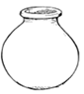**Name the pictures below;**

**_____________________**

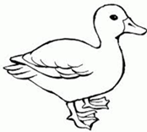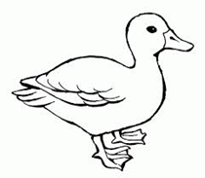



**_________________**

1. **Write the missing letter.**
2. el ___ph____nt
3. b___sket
4. **Use ‘a’/ ‘an’ to fill in the gaps.**

That is ______________ lion.

My uncle saw ______________ eagle in the bush.

There is _____________ antelope.

1. **Arrange the words in alphabetical order.**

goat, hen, cow, pig

_________________________________________________

cub, camel, coat, cell

_________________________________________________

1. **Use: Yes, they are. / No, they are not.**

 Are these baskets**?**

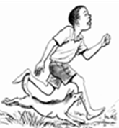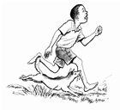 ____________________________________

Are they running**?**

__________________________________

1. **Use the verb in brackets correctly.**
2. Andrew is __________________ a book now. (read)
3. She ____________ her uniform every morning. (wash)
4. They _____________ the classroom yesterday. (clean)
5. **Write the following in full.**

Dr. ______________________

Rd. ______________________

1. **Write the young ones of these animals.**

pig ___________________

goat ___________________

1. **Complete the table correctly.**

|  |  |  |
| --- | --- | --- |
| **tall** | **taller** | ________________ |
| **big** | _______________ | **biggest** |

1. **Give the opposites of the underlined words.**
2. My mother is kind. ____________________
3. Those boys are very dirty. ____________________
4. Our grandfather stays near. ________________
5. **Use some / any to fill the gaps.**
6. There isn’t ________________ tea in the cup.
7. We have _____________ mangoes in the basket.
8. **Circle the odd man out.**
9. apples, mangoes, goats, pineapples.
10. calf, kitten, chair, piglet.
11. **Write a small word from a big word.**

cockroach ______________________

butterfly ______________________

1. **Give the plural form of the circled words.**
2. Musa ate a mango. _____________________
3. A dog produced a puppy. _________________
4. **Re-arrange the words to make a good sentence.**
5. gives us milk A cow.

_______________________________________________

1. goes to the Annet market every day.

________________________________________________

1. **Re-write the sentences as instructed in brackets**.

I am sad. I have lost my money. **(Use: …because……)**

___________________________________________________

Alice is a girl. Aminah is a girl. **(Join using:…….and……)**

___________________________________________________

Daddy is milking a cow. Mummy is cutting grass. **(Join using:……..but…………)**

___________________________________________________

That is the woman. She lost her bag.**(Join using:..who…)**

___________________________________________________

This is a dog. **(Begin: These………………………….)**

____________________________________________________

1. **Read the story and answer the questions in full sentences.**

**MY CLASS**

My name is Alice. I am eight years old. I live at Kiti. I go to Kibbo Primary School. My class is primary two. My class teacher is Ms. Namala Hawa. She teaches us how to make things out of local materials. We make balls, baskets, ropes and hats from banana fibres.

I love my class teacher very much.

**Questions**

1. Write the title of the story.

_______________________________________________

1. How old is Alice?

_______________________________________________

1. In which class is Alice?

_______________________________________________

1. Where does Alice live?

________________________________________________

1. **Read and draw good pictures.**

These are two books.

He is driving a lorry.

1. 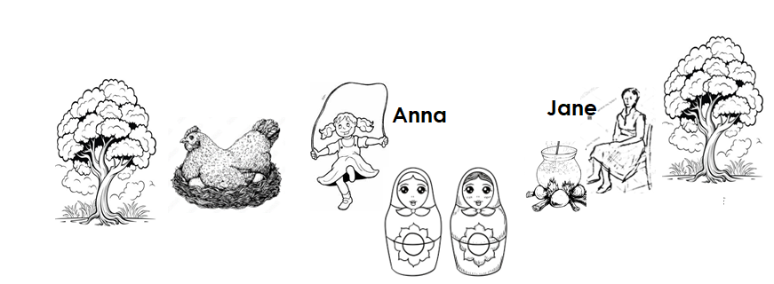**Picture composition.**

1. Jane is sitting on a _____________________
2. How many trees are there?

________________________________________________

1. What is Anna skipping?

_________________________________________________

1. **Match and write the sentences correctly.**

|  |  |  |
| --- | --- | --- |
| A bicycle  A lamb  A stool | is | for sitting on.  used for transport.  a young one of a sheep. |

1. _____________________________________________
2. _____________________________________________
3. _____________________________________________

**END**